**Computer Networks**

**Lab 03**

**In Lab Statement 01:**

**http-ethereal-trace-1**

**Question no.01:**

The four unfiltered protocols are:

1. SNMP
2. DNS
3. TCP
4. HTTP

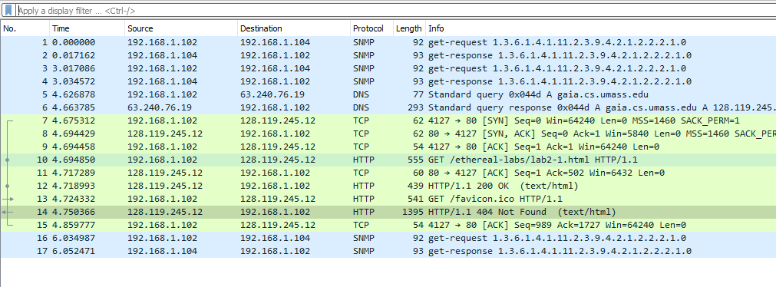

**Question no.02:**

Time when http get message was sent: 4.694850

Time when http OK message was received: 4.718993

Time Taken: 4.718993 - 4.694850

Time Taken: 0.024143s

**Question no.03:**

No, the second get request was not successful because the info against that protocol said “404 not found”.



**Question no.04:**

The browser is running version 1.1 and similarly the server is also running version 1.1 as it can be clearly seen in the packet listing pane’s info column.

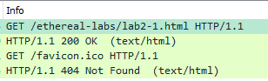

**Question no.05:**

The browser accepts US-English language which is seen in the packet detail’s pane.

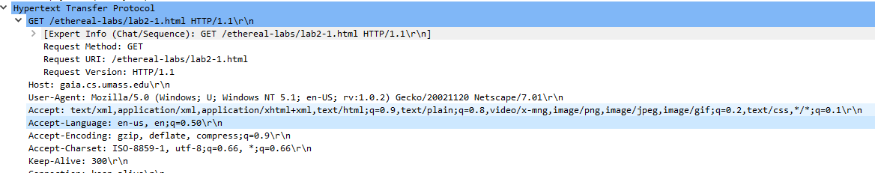

**Question no.06:**

IP Address of gaia.cs.umass.edu server and my computer:

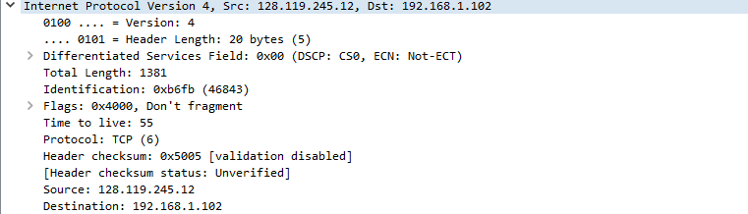

The source gives the IP address of the server.

The destination gives the IP address of my computer.

**Question no.07:**

The MAC address of my computer is :



**Question no.08:**

Sending port number: 80

Receiving port number: 4127



Port no.80 represents our computer’s port that sends the get request.

**Question no.09:**

Status code from server to browser: 200



**Question no.10:**

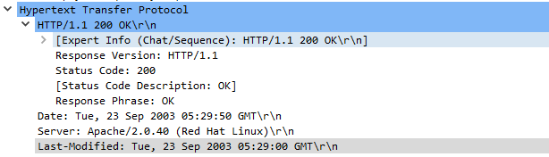

**Question no.11:**

Total packet content byes: 439 bytes



**http-ethereal-trace-2**

**Question no.01:**

No, I do not see any “if-modified-since” line.

**Question no.02:**

Yes, the contents are returned explicitly.

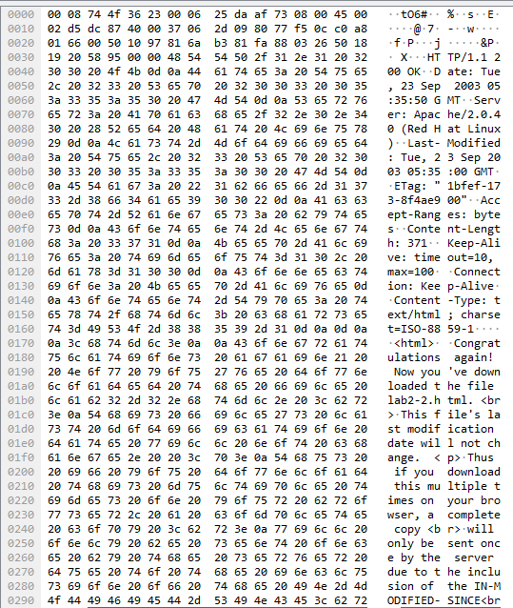

**Question no.03:**



Yes, we can see the “if-modified-since” line and it indicates the time when the file was last modified/downloaded**.**

**Question no.04:**

Status code: 304

Phrase: not modified

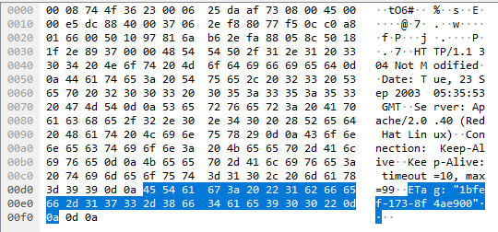

**In Lab Statement 02:**

**Question no.05:**

The browser sent only one GET request message.



**Question no.06:**

Packet number: 08

**Question no.07:**

Packet number: 14

**Question no.08:**

Status code: 200

Phrase: OK

**Question no.09:**

Only one data containing TCP segment was needed to carry the response and the packet number was: 15



**In Lab Statement 03:**

The length of the last packet is length 490 bytes because all other packets have been assigned their bytes and the only remaining bytes were 436. It had to add up to 4816 bytes so that’s why it couldn’t exceed 436 bytes. Secondly, the total length should be 4500 bytes but the final length after adding the packets was 4816 bytes because it had to add the headers of packets too.